Lab Objective

Troubleshooting DNS

**Lab Procedures**

**1.** On RWDC01, at the command prompt, execute the following command:

nslookup PC1.adatum.com

**2.** To start nslookup in interactive mode, execute the following command:

nslookup

**3.** To display the SOA record for adatum.com domain, execute the following commands:

set type=soa

adatum.com

**4.** To display the MX record for the adatum.com domain, execute the following commands:

set type=mx

adatum.com

**5.** Take a screen shot of the Command Prompt window by pressing Alt+Prt Scr and then paste it into your Lab09_worksheet file in the page provided by pressing Ctrl+V.

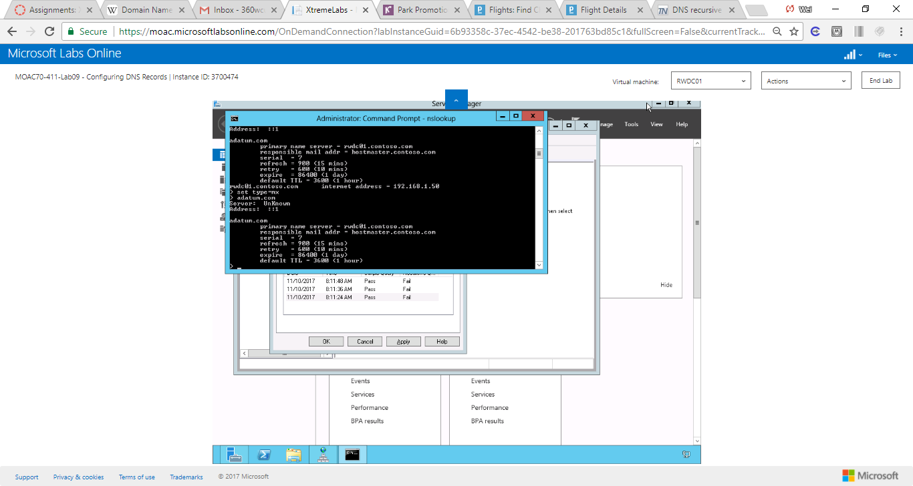

Figure 1Take a screen shot of the Command Prompt window

**6.** Close the Command Prompt.

**7.** On RWDC01, with DNS Manager console, right-click the RWDC01 and click Properties. The properties dialog box opens.

**8.** Click the Monitoring tab. Figure 9-4 shows the Monitoring tab.

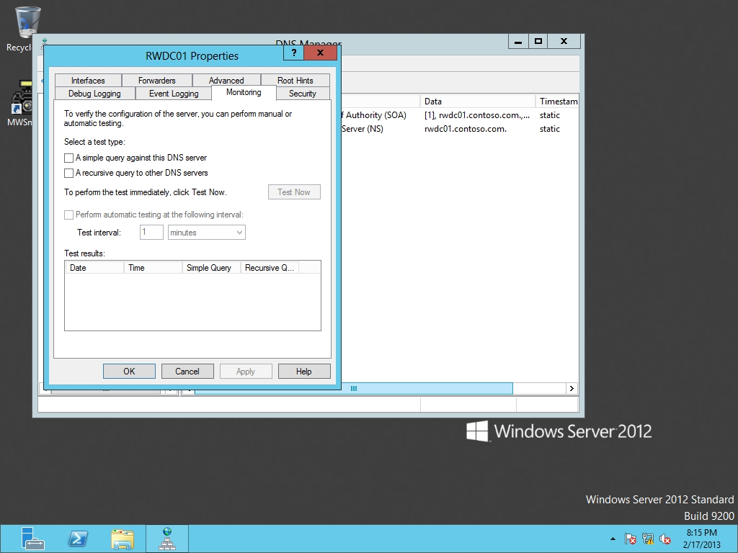

Figure 8-4

Monitoring the DNS server

**9.** Select to enable the following settings:

A simple query against this DNS server

A recursive query to other DNS servers

**10.** Click Test Now.

|  |  |
| --- | --- |
| Question 16 | Did either simple query or recursive query fail? If a failure did occur, why did it fail?  The recursive query fails. It might be caused by the query is disabled, or the other DNS servers are configured correctly |

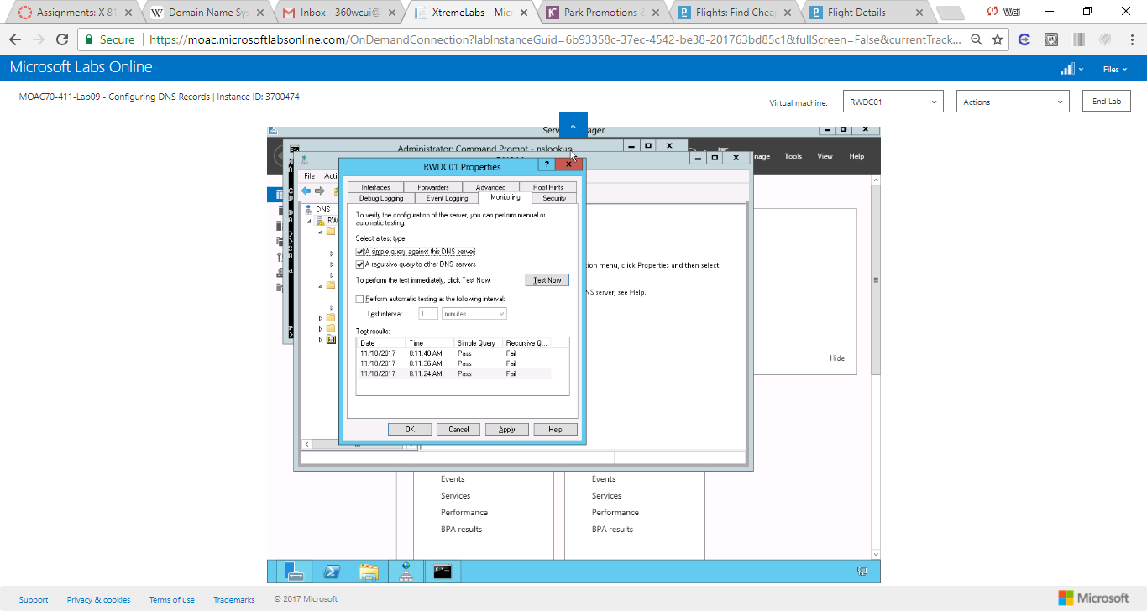

Figure 2 DNS server test results. The recursive query fails. It might be caused by the query is disabled, or the other DNS servers are configured correctly.

**11.** Click OK to close RWDC01 Properties.

**12.** Close DNS Manager.

**Lab Summary**

During this exercise, I used nslookup in other ways to test DNS. I also used the DNS built-in tools to test DNS. The built-in tools are accessible from DC properties->monitoring->check check box a simple query against this DNS server or check check box a recursive query against other DNS servers. In addition, we can use command window to test DNS queries.